Instructions and Shopping List for Compost Tea Brewing in a 5 gallon bucket: +-$120

For the recipe, I use these measurements for a 5-gallon bucket:

1.5 tablespoons kelp
1 teaspoon fish hydrolysate
3-4 drops humic acid
1 lb. Worm castings

Fill CLEAN 5-gallon bucket with water.
If chlorine in water, let sit overnight

Next Day:
  - Set up your aquarium air pump, with 4 tubes
  - Add aquarium pump tubing to bottom of bucket, secure with flat stone
  - (make sure aquarium pump is sitting ABOVE the tubes, to avoid flooding if turned off)
  - Add amendments, let bubble for 10 minutes
  - Add worm castings to 400-micron mesh bag, use bag handle to hold stick over bucket
  - Bubble for 24 hours, apply right away, as foliar spray and root drench

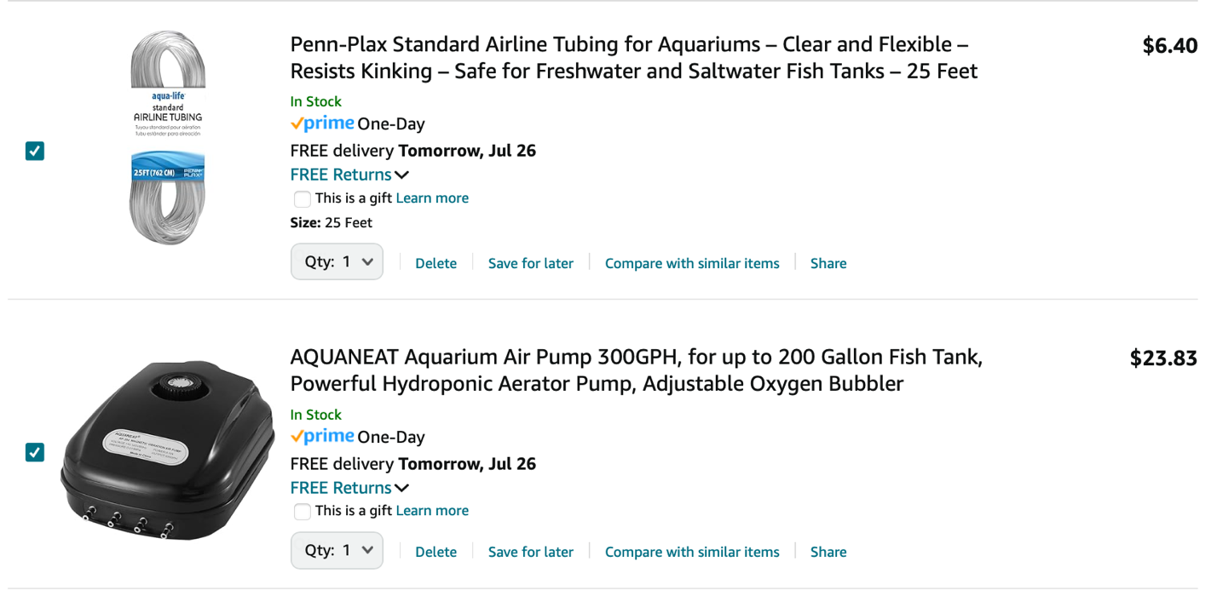
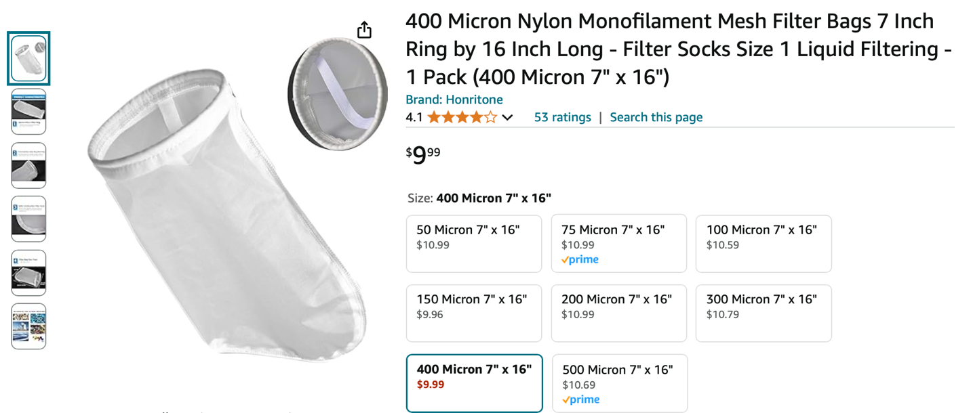
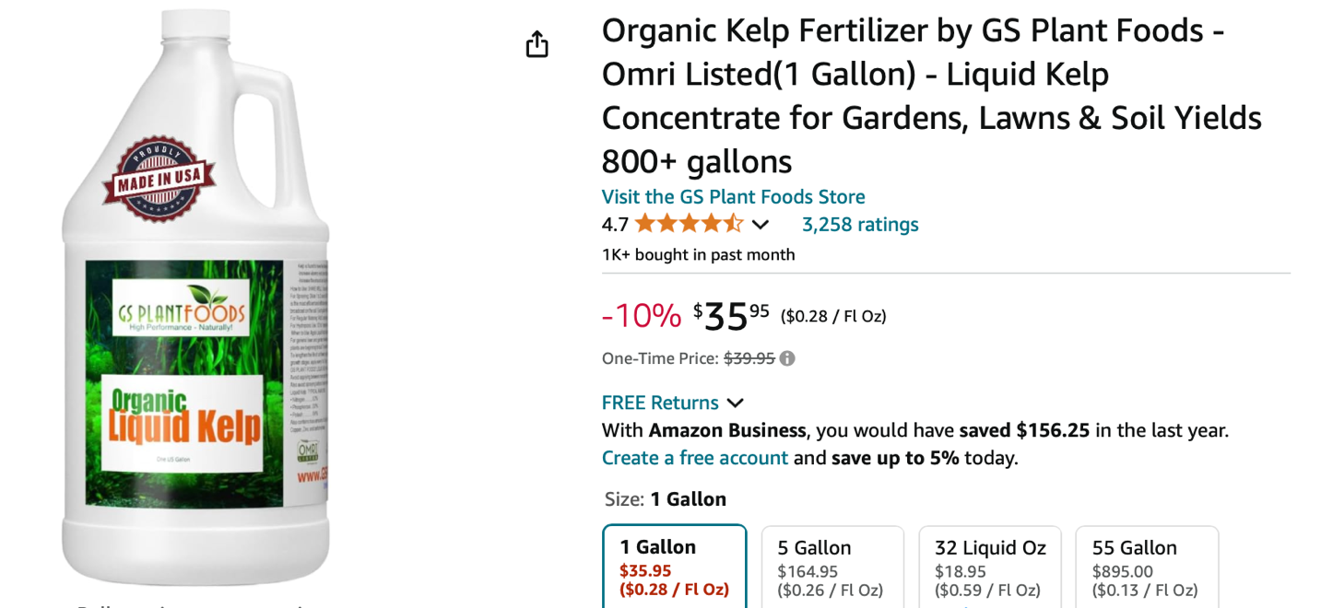

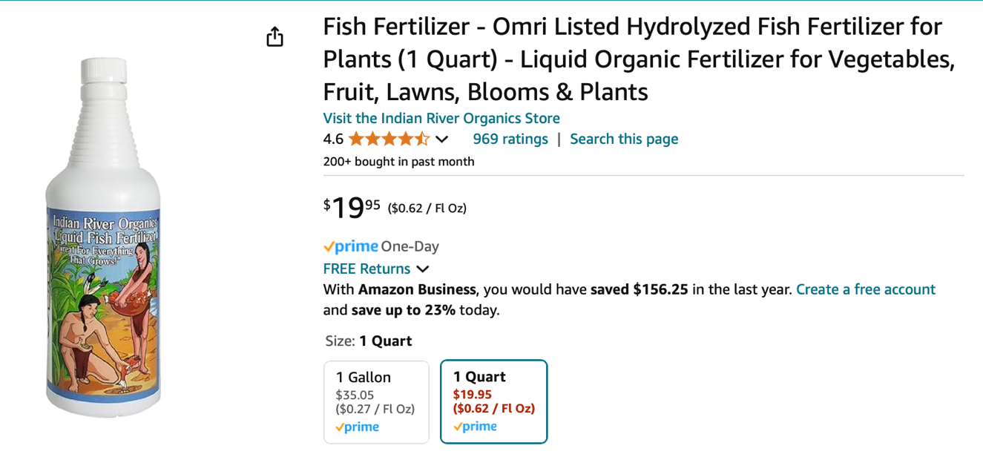
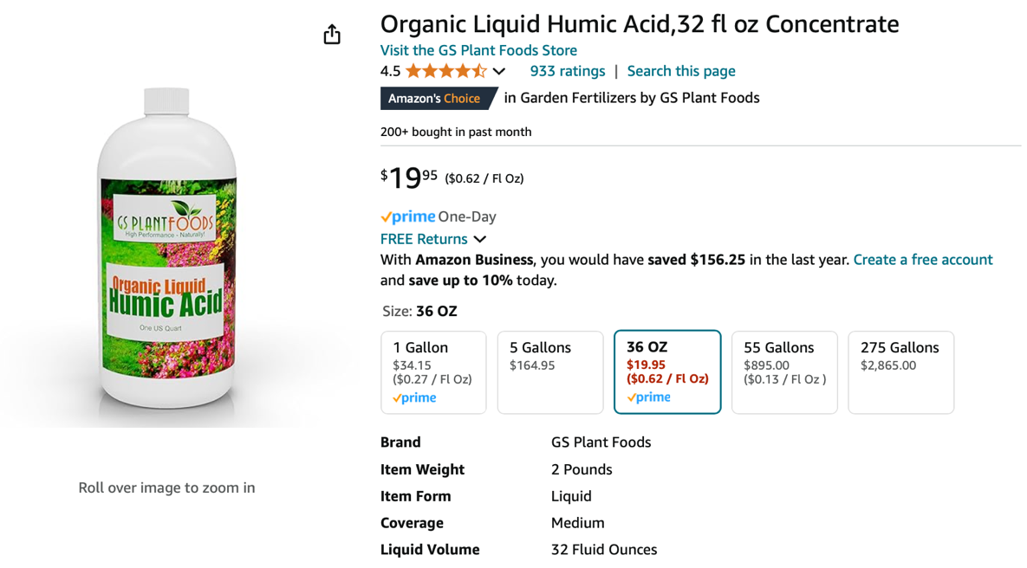

Tubing: https://www.amazon.com/gp/product/B0002563MW/ref=ox_sc_act_title_1?smid=ATVPDKIKX0DER&th=1

Air Pump: https://www.amazon.com/gp/product/B088THVBZF/ref=ox_sc_act_title_2?smid=A1W7R5UJZCLN8X&psc=1

400 micron mesh bag :
https://www.amazon.com/Filter-400Micron-Liquid-1Pack-Micron/dp/B082S76WKD/ref=sr_1_5_pp?crid=3C62ZOX78BAM2&dib=eyJ2IjoiMSJ9.XGf6z-REWI9UJtqWki_oBryp8-VeZy2QxTVkzOsRk0WIDSVWWyAlX_tYVEN3kVaHEIuSjlJUi-QS7harzMjp1JSGScmkctNqb4wY4oolxkYtWoiGp0DO2eaSdtAa-eznbZdFUvzeWYjcWOgg9NCpMFgmu12NUIQH_qnwp7gODG0e9jYNwUk4iCXQK-9_TEB5HGEJE-7jv8pvHO0GuAZA0VQ4-6ZgqRkkegBXqwMn0RAr-lwJ80xU3A9p40MuGb37SqLbhiuHIBvnzEQu0L6VfYJpjlAwpsWmYu7BDoxuspg.zhgAe7PNTHmR6x27jw2wRxTJRe29LdLGn5bJ6mhcDNA&dib_tag=se&keywords=400%2Bmicron%2Bmesh%2Bbag&qid=1722359539&sprefix=400%2Bmicron%2Bm%2Caps%2C118&sr=8-5&th=1

Liquid Kelp:
https://www.amazon.com/GS-Plant-Foods-Fertilizer-Concentrate/dp/B089HSJQ4Q/ref=sr_1_2_sspa?crid=3BCEFE10VF7G7&dib=eyJ2IjoiMSJ9.LS7gZasPIaWvq2jYPY_HLeyeii0-QQnPuWWOkGMM8OpIcP_U14uB1o8OXnQ5Vszaqaqt5QXwsypSc94i0qsUSsuBkXk6uaEJZD_yRWYkgquK2YYYQz5eYPOaMZ4SDy8dGebGuXPYeXP3XwKZYDt95mCZj9dfGzl6Tf9n-k1G6M9ZmXBGCrRIRKD1oY-HZ6U4apr-3GTP6GvqMRgR0nOWY3cdP9hlVRCV1FNNeql4QHnghNhoMd6GCWdNbknd-UgJEt6ri447daISC-ztIFeHGjuG-K4FTcjE3i_qDxFg4mA.jiVtoWb5933jFCU9VZDI8x6ZQ-gJdIQRHUHiEJvKo0E&dib_tag=se&keywords=liquid%2Bkelp&qid=1771435767&s=lawn-garden&sprefix=liquid%2Bkelp%2Clawngarden%2C180&sr=1-2-spons&sp_csd=d2lkZ2V0TmFtZT1zcF9hdGY&th=1

Fish Hydrolysate: https://www.amazon.com/Indian-River-Organics-Hydrolyzed-Fertilizer/dp/B01M5GV8HV/ref=sr_1_4?crid=2GF7Y1XW3BCW3&dib=eyJ2IjoiMSJ9.VNhB1DK_HTauK-f9628eIkQJ-SgPkm-7PCfMQ4ieNew7z_TuRXmX5AQjji-t08UEzzsMz5XK-OqiPRdApFkVYX-LRNTlWbg98rVWJMl_5g4N2Vhkv0alTUAA0scfsWR9BAQ2J0JM3xNniRvA9UO8Uw8UDnp-budvNslgEGNopwRzq-o54xwuHjmu09HQX5pHABVfXwBT7chJ_ODa0UTHcpBnmQRlRIJUI2Ar4GF2U71qI1lbnoKaQX0pBk3v_m-5GmTD9QmlCffVcQ_Ynj2JGXk8sgNZ-eCFKQvGXZ7-dw0.MtgxlrhYZETGbeDGZ8PxfMD5Jabhxqxn7YD8bH8ZJoY&dib_tag=se&keywords=liquid%2Bfish%2Bhydrolysate&qid=1722359915&s=lawn-garden&sprefix=liquid%2Bfish%2Bhydro%2Clawngarden%2C87&sr=1-4&th=1

Humic Acid : https://www.amazon.com/Organic-Liquid-Humic-Acid-Concentrate/dp/B00CSAMK4E?pd_rd_w=NWPEY&content-id=amzn1.sym.55c0153f-1fb7-42ff-8241-d1c0f3732289&pf_rd_p=55c0153f-1fb7-42ff-8241-d1c0f3732289&pf_rd_r=2480G0P6FNJC4XAYCK1V&pd_rd_wg=Es7PV&pd_rd_r=bd99ed54-d624-4b7c-a044-ea3ce96f1f3d&ref_=sspa_dk_detail_2&th=1

